

CS 320 Course Project - Software Design Document

for

<Project>

Prepared by

Group Name: <*place your group name here*>

|  |  |  |
| --- | --- | --- |
| <name> | <student #> | <e-mail> |
| <name> | <student #> | <e-mail> |
| <name> | <student #> | <e-mail> |
| <name> | <student #> | <e-mail> |
| <name> | <student #> | <e-mail> |

|  |  |
| --- | --- |
|  |  |
| Date: | <place the date of submission here> |
|  |  |
|  |  |
|  |  |

Content

Contents ii

1 Introduction 1

1.1 Project Overview 1

1.2 Definitions, Acronyms and Abbreviations 1

1.3 References and Acknowledgments 1

2 Activity Diagram(s) 2

2.1 D-1 2

2.2 D-2 2

2.2 D-3 2

3 Class Diagram(s) 3

3.1 D-1 3

3.2 D-2 3

3.2 D-3 3

4 Behavioral Diagram(s) 4

4.1 D-1 4

4.2 D-2 4

4.3 D-3 4

Appendix A - Group Log 5

< A table of contents

Edit this table as needed to suit the page numbers and titles of the diagrams you included. >

# Introduction

*<TO DO: Please provide a brief introduction to your project.>*

## Project Overview

< A brief description of the project and the diagrams.

TO DO: Write 1 paragraph explaining the project and anything of unique relevance for the diagrams included in this document. At minimum this should include which type of behavioral diagram your system will use.>

## Definitions, Acronyms and Abbreviations

<Define all the terms necessary to properly interpret the report, including acronyms and abbreviations.

TO DO: Please provide a list of all abbreviations and acronyms used in this document sorted in alphabetical order.>

## References and Acknowledgments

<List any other documents or Web addresses to which this document refers

TO DO: Use the standard IEEE citation guide for this section.>

# Activity Diagram(s)

## Making a Journal Entry

The user will be signed in at the start of this diagram. When they go to make a journal entry, the system generates a list of the color presets the user can choose from. The user can then choose what color the background of their journal entry can be. The computer will then generate mood presets and the user will choose one. From there, the user can review the entry and either accept or reject it. If the user rejects it, they will be sent back to the start of the process. If the user accepts the entry, they will be redirected to where they can review all previous entries.

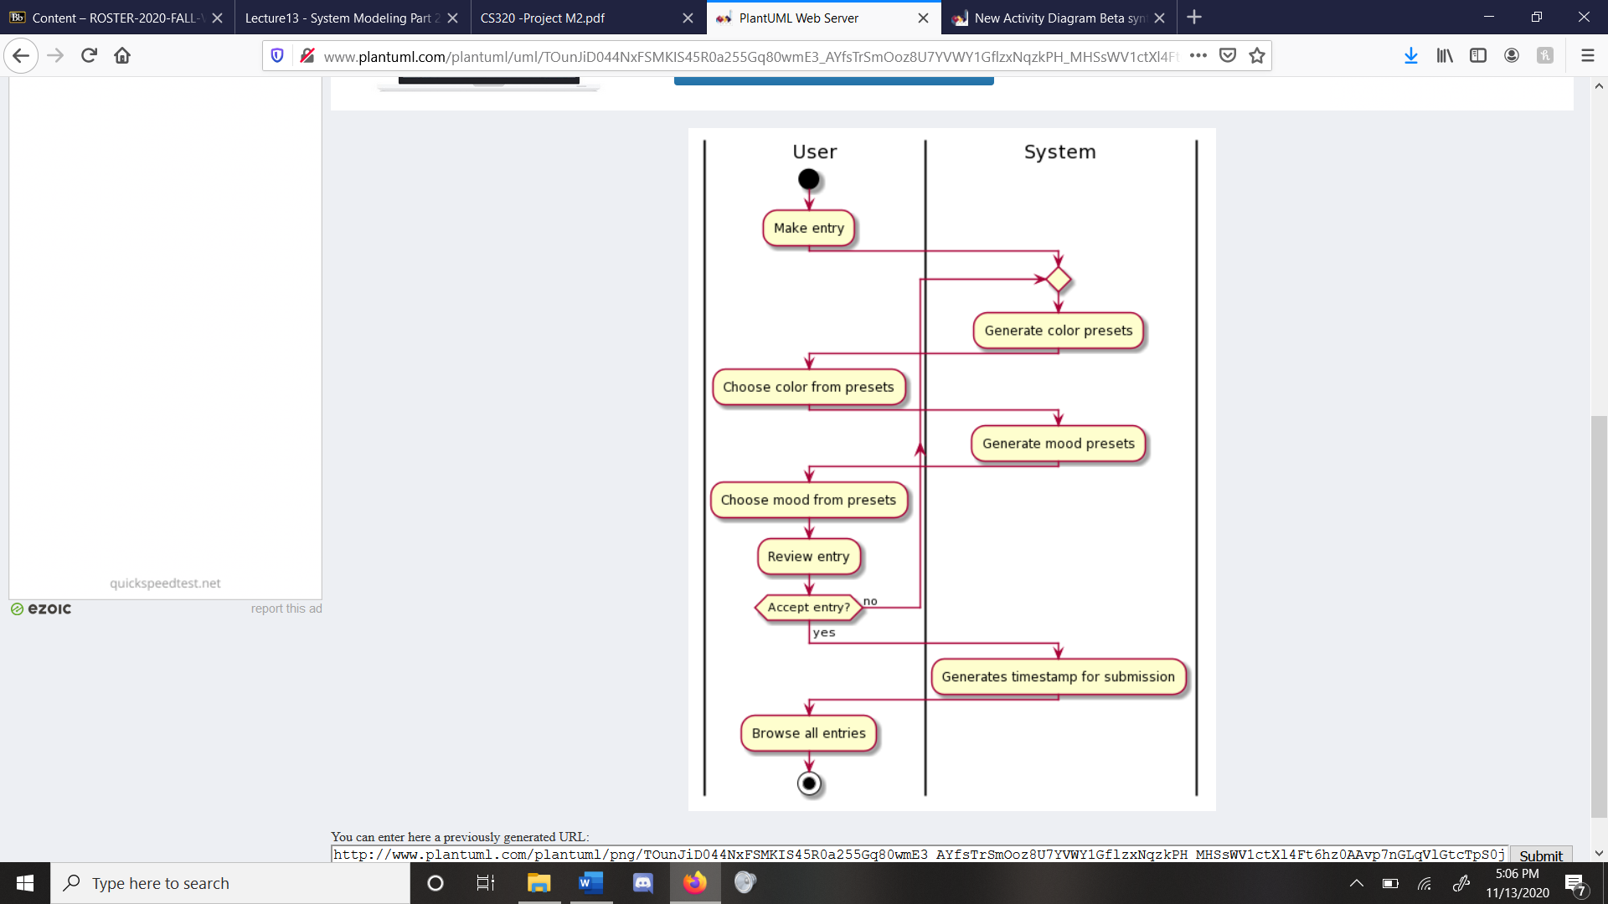

Figure 1: Making a Journal Entry

## D-2

<Same as for D-1, repeat for as many diagrams as you have for this section. Remove if not needed.

TO DO: Repeat same process as you did for D-1: Title, Diagram, Description, Traceability.>

## D-3

<Same as for D-1, repeat for as many diagrams as you have for this section. Remove if not needed.

TO DO: Repeat same process as you did for D-1: Title, Diagram, Description, Traceability.>

# Class Diagram(s)

## D-1

<Provide a title, the class diagram, and a table with the classes along with their descriptions.

TO DO: Provide a class Diagram for your program that shows the classes that exist for the system and their association, composition, and generalization. Provide a table underneath with a brief 1-2 sentence description of each class and their use within the system. Replace the title, D-1, with a more meaningful one.>

## D-2

*<Same as for D-1, repeat for as many diagrams as you have for this section. Remove if not needed.*

*TO DO: Repeat same process as you did for D-1: Title, Diagram, Classes and their Descriptions. >*

## D-3

*<Same as for D-1, repeat for as many diagrams as you have for this section. Remove if not needed.*

*TO DO: Repeat same process as you did for D-1: Title, Diagram, Classes and their Descriptions. >*

# Behavioral Diagram(s)

## <*This section will have either sequence diagrams or state diagrams. This will depend on if you system is data-driven (sequence) or event-driven (state).>*

## D-1

<Provide a title, the behavioral diagram, and a brief description about it.

TODO: Provide a Behavioral Diagram (sequence or state) and then give a description of what activity it is describing visually. For sequence diagrams, this would be each actor involved and the function calls between them. For state diagrams, this would be a table of each state with each state transition also labeled and described. A series of related complex states should be simplified as a “superstate” with a more in-depth view of it shown in a separate diagram. See the “operation” state in the microwave state diagram from Lecture 13 slides 27 and 28 for an example of this.>

## D-2

<Same as for D-1, repeat for as many diagrams as you have for this section. Remove if not needed.

TODO: Repeat same process as you did for D-1: Title, Diagram, Description.>

## D-3

<Same as for D-1, repeat for as many diagrams as you have for this section. Remove if not needed.

TODO: Repeat same process as you did for D-1: Title, Diagram, Description.>

Appendix A - Group Log

< Please include here all the minutes from your group meetings, your group activities, and any other relevant information. This should contain and continue the contents from the SRS. This is optional for one-person projects.>